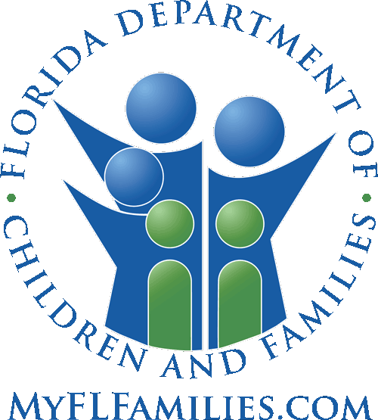

**Circuit 14 Community Alliance for Families**

**Bimonthly Meeting Agenda**

**September 12th, 2024 at 10-11:30am CST via Microsoft Teams**

**Board Members**

**Chair:** Lori Allen, Gulf Coast Children’s Advocacy Center

**Co-chair: open**

**Secretary:** Tara Taylor, Northwest Florida Health Network

**DCF representative:** Missy Lee, C14 Community Administrator

**Welcome and Approval of Minutes:**  Lori Allen, Chair

**Standing agenda items** **(max 8 minutes each):**

NW Florida Health Network (CBC & ME) Kelly Faircloth, C14 Administrator

DCF/ Child Welfare Matt Mayo, Operations Review Specialist

Hope Florida Data Cecelia Salter-Castleberry, Program Director

Gulf Coast Children’s Advocacy Center Lori Allen, Executive Director

Community updates/ LRT data Missy Lee, DCF C14 Community Dev Adm

**Community Highlights/ Resources Update/ Group Discussions (10 minutes):**

Share Your Heart Faith Based Partner update Bill Wright and Manny Arisso, Area Directors

C14 Alliance workgroups update Lori Allen, Chair

**New Business**

Nominations for secretary position Lori Allen, Chair

**Old Business**

**Open Forum (2 minutes per agency)**

**Adjourn**

**Next Meeting:**

**Thursday, November 14th, 10am-11:30pm CST**

Mission of the Circuit 14 Community Alliance - We, members of the Circuit 14 Community Alliance, are community stakeholders committed to improving the lives of today’s children and families by assuring them appropriate community resources to match their needs to be productive members of tomorrow’s community.

To be added to the agenda, please contact Missy Lee, [**Mylisa.lee@myflfamilies.com**](mailto:Mylisa.lee@myflfamilies.com)**,** Circuit 14 Community Development Administrator**,** 850-251-7350 *each agenda item, after all motions and member discussion, shall provide for public comment for a maximum of 2 minutes per person with a 10-minute overall limit.

Pursuant to the provisions of the Americans with Disabilities Act, any person requiring special accommodations to participate in this workshop/meeting is asked to advise the agency at least 48 hours before the workshop/meeting by contacting: Joshua Burns at [Joshua.Burns@myflfamilies.com](mailto:Joshua.Burns@myflfamilies.com).  If you are hearing or speech impaired, please contact the agency using the Florida Relay Service, 1(800)955-8771 (TDD) or 1(800)955-8770 (Voice).