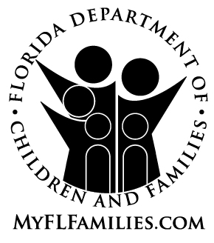 | LIFE SKILLS PROGRESS DOCUMENTATION LOG

Name of Youth or Young Adult |  | Age |  | Date

Check the NYTD Skills Categories Covered
Children and young adults in out-of-home care acquire independent living skills that have been paid for or provided by the Department and its contracted service providers using Chafee program funds. Each of the skills will fall into one or more of the following NYTD categories:

Academic  Support | Post-Secondary Educational Support | Career Preparation | Employment Programs or Vocational Training | Budget and Financial Management
Mentoring | Housing Education & Home Management Training | Health Education and Risk Prevention | Family Support and Healthy Marriage Education | Supervised Independent Living

Topic/Skill(s) Addressed:

Learning Goal(s):

Assessment of Competency:

Plan for Competency:

Person(s) attesting:

Caregiver | Date

Child Welfare Professional | Role | Date

Designated staff shall upload this form into FSFN Independent Living Filing Cabinet under the Image Category called Assessments.

