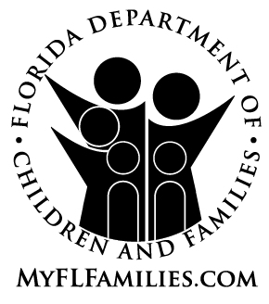 | ORAL REQUEST FOR FAIR HEARING

Community-based care (CBC) or Department staff must use this form to document oral requests for fair hearings from young adults. A request for a fair hearing may be oral or written, although the young adult is encouraged to submit it in writing. Within one (1) business day of receipt of an oral request, CBC staff shall forward the form and a copy of the original notice of adverse action to the legal representative for the Department and the Department’s Office of Appeal Hearings.

Florida Department of Children and Families (Please check the applicable program.)
Extended Foster Care
Postsecondary Education Services and Support (“PESS”)
Aftercare Services

This oral request for fair hearing is documented by:

Name (Case Manager/Designated Staff) |  | Date

Address City State Zip Code

Phone Number (including area code),  and extension number, if applicable |  | Email

A hearing has been requested by:

Name |  | Date of Birth

Address City State Zip Code

Phone Number (including area code) |  | Email

Date of Request

has decided to take the following action
regarding the individual’s eligibility for or receipt of one of the above-listed services for young adults formerly in foster care:
_______________________________________________________________________________________________________________________________________________________________________________________________________________________________________________________________

The individual has stated that he/she is not satisfied with this action and is requesting a hearing for the following reasons:
_______________________________________________________________________________________________________________________________________________________________________________________________________________________________________________________________

This hearing request must be faxed or e-mailed within one (1) business day to the following addresses. For individuals who do not have a fax number or e-mail address, this hearing request shall be sent by certified mail. A copy of the notice to which this request pertains should accompany this request for hearing.

1. Department of Children and Families
Office of Appeal Hearings
1317 Winewood Boulevard
Tallahassee, FL 32399-0700
Fax: (850) 487-0662
E-mail Address: Appeal_Hearings@myflfamilies.com

2. Young Adult:
Name: ___________________________________________________________
Address: __________________________________________________________________________
City, State, Zip Code: ___________________________________________________________
Telephone Number/E-mail: ___________________________________________________________

3. Young Adult’s Authorized Representative (if applicable):
Name: ___________________________________________________________
Address: __________________________________________________________________________
City, State, Zip Code: ___________________________________________________________
Telephone Number/E-mail: ___________________________________________________________

4. Department of Children and Families’ Regional Legal Counsel
Name: ___________________________________________________________
Address: __________________________________________________________________________
City, State, Zip Code: ___________________________________________________________
Fax: ______________________________
Telephone Number/E-mail: ___________________________________________________________

5. Department of Children and Families’ Legal Representative
Name: ___________________________________________________________
Address: __________________________________________________________________________
City, State, Zip Code: ___________________________________________________________
Fax: ______________________________
Telephone Number/E-mail: ___________________________________________________________

