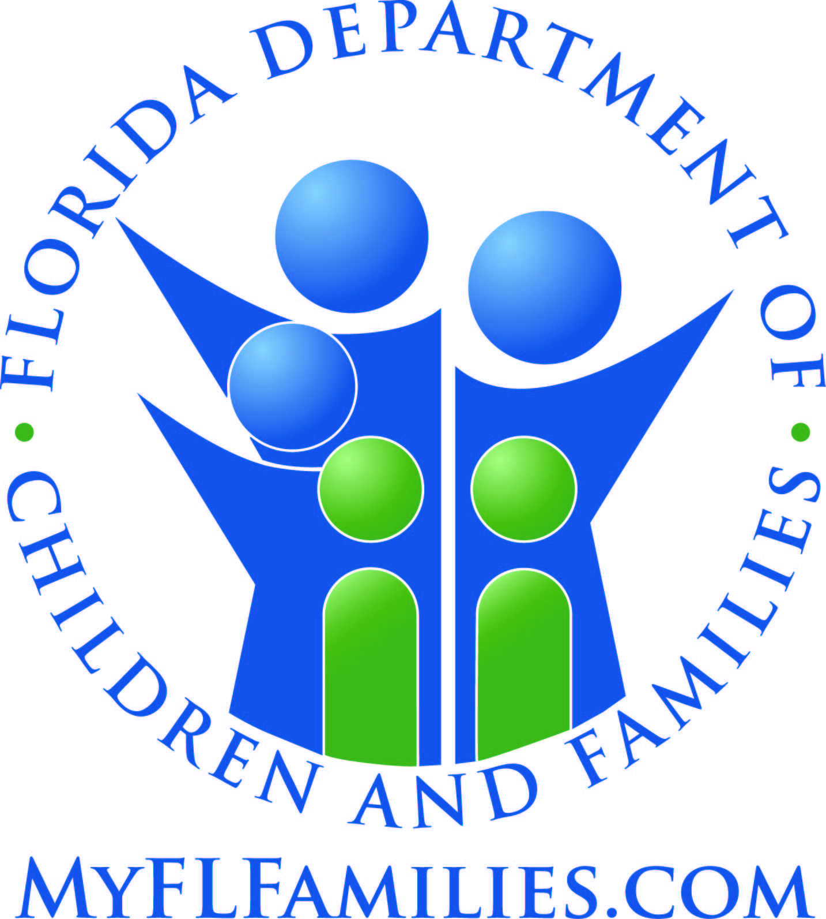 | DUE PROCESS RIGHTS

Under Extended Foster Care, Postsecondary Education Services and Support (“PESS”), and Aftercare Services, you have the right to appeal eligibility decisions based on the Code of Federal Regulations and under Florida Statutes (F.S.).

Title 45, section 205.10 of the Code of Federal Regulations provides for “fair hearings,” which are used to challenge or appeal actions relating to federally funded services. Sections 39.6251(9) and 409.1451(4), F.S., provide for an appeal, which can be provided by a fair hearing. Florida Administrative Code Chapters 65C-41 and 65C-42 explain this in more detail.

Rights to a Fair Hearing
You have the right to a fair hearing when you have been denied the right to participate in the Extended Foster Care program, i.e., have an application denied, or if you have been discharged (removed) from Extended Foster Care. NOTE: If you are dissatisfied with the services you receive in the Extended Foster Care program (for example, the choice of your living arrangement, your supervision, or the allowance amount), you may raise those issues with your dependency judge in a court hearing.
You also have the right to a fair hearing if you have any disagreement concerning PESS and Aftercare services.
You may request a fair hearing when a request for services is denied, when the Department or its contracted service provider fails to act on a request for services within 10 business days of that request, or when services you are currently receiving are reduced or terminated.
What is a fair hearing? A fair hearing is an administrative appeal by an individual when the Department or your community-based care provider takes any action that affects your participation in the program. This may include the denial of assistance (i.e., a denial of an application), a delay in acting on a request for assistance, a reduction or change in services, or termination of services.
When may I request a hearing? You or your authorized representative may request a fair hearing when the Department or any agency contracted to take action on behalf of the state takes an action to reduce or terminate (stop) services. A fair hearing may also be requested when an agency denies or fails to act on your request for assistance.
You have 30 calendar days from the date of the notice you received to request the fair hearing. If services you currently receive are being reduced or terminated, you have 10 business days from the date of the notice of this reduction or termination to ask for a hearing and to continue to get your services at the same rate until the appeal is concluded.
How do I request a fair hearing? You must submit a request, preferably in writing, to the community-based care provider providing you with independent living services or the Department of Children and Families Office of Appeal Hearings in Tallahassee, no later than 30 calendar days from the date the notice of the community-based care provider’s action was received by you. No one may interfere with your right to request a fair hearing. Your community-based care provider can assist you in making your request. You may also speak with your case manager/designated staff and say you want to request a fair hearing. But putting it in writing is best. A written form to ask for a fair hearing is attached to this paper.
You have the right to review your records and any other documents the community-based care provider will use at the hearing.
What happens when I request a fair hearing? In most instances, if you request a hearing, your request will be granted. If your request for a hearing is denied, you will be notified in writing of the denial. You may appeal any written denial to the appropriate District Court of Appeal.
When you make a request for a fair hearing and the request is granted, what occurs next depends on whether you have been receiving the services and support that are at issue. If you have been notified that a request for services has been denied or if there has been a delay in acting on your request, the services will not be provided unless you win the fair hearing.
When you are notified that your services are to be reduced or terminated, and you have requested a fair hearing within 10 business days of the date you received notice of the reduction or termination of services, the services will continue uninterrupted until the hearing process is completed.
If you win your case at the hearing, services will continue. If you do not win your case at the hearing (challenging the proposed reduction or termination of services), your services will be discontinued.
What are the steps in the fair hearing process? The first step in the fair hearing process is a local review of the evidence by the Department or the community-based care provider. If the issue is resolved on the local level to your satisfaction, you should then withdraw your request for a hearing.
If your issue is not resolved and your request is not withdrawn, the next step is a hearing conducted by a hearing officer from the Office of Appeal Hearings. You will receive written notice of the time, date and place of the hearing.
How do I prepare for a fair hearing? You have the right to bring witnesses, present your side of the story, and question or contradict any testimony or evidence presented. You may present your own case to the hearing officer or bring an attorney, relative, friend or other spokesperson to represent you. If you cannot afford an attorney, you can ask your case manager or independent living coordinator for help in finding an attorney, or you can ask your local Legal Aid Society for an attorney.
What is a final order? After considering the evidence presented at the hearing, the hearing officer will prepare a written final order within 90 days. If the hearing officer finds that the action taken was correct, then whatever your agency did will be upheld. If the hearing officer finds the action taken was wrong, he or she will say what corrective action should happen, and it will be corrected back to the date of the incorrect action.
If I lose, is there anything else I can do? You have the right to appeal the hearing officer’s written order to the District Court of Appeal. Although you can represent yourself, you really should have an attorney handle that for you. You can hire an attorney. If you cannot afford an attorney, you can ask your case manager or independent living coordinator for help in finding an attorney, or you can ask your local Legal Aid Society for an attorney.
You also have the right to re-apply for the service after you lose. You can re-apply for Extended Foster Care at any time until your 21st birthday. You can re-apply for PESS and Aftercare Services at any time until your 23rd birthday. Keep in mind, though, that there are requirements for you to be accepted into the Extended Foster Care and PESS programs, and for you to receive funding or services through Aftercare Services.
You also have the right to apply for a different service than the one you previously were denied or discharged from. For example, if your application for PESS or for Extended Foster Care was denied and you lost the appeal, or you were discharged from (removed from) PESS or Extended Foster Care, you can apply for Aftercare Services to help you move to independence. If you are under 21 and you do not qualify for PESS, you can apply to re-enter Extended Foster Care.
If you still need and want help, talk with your case manager or independent living coordinator to see what other assistance is available to you.

Additional information on your right to a fair hearing may be found in Title 45, Section 205.10, Code of Federal Regulations, and Rules 65-2.042 through 65-2.069, Florida Administrative Code.

Attachment: Form CF-FSP 5380, Request For Fair Hearing [copy to be provided by Case Manager]

