**Guardianship Assistance Program**

**(GAP)**

**Session A**

**June 2019**



**Contents**

**Session A** 3

**Objectives** 3

**Title IV-E Waiver Expiration** 5

**Title IV-E Waiver** 5

**Title IV-E Waiver Expiration** 5

**Path Forward** 5

**Caregiver Benefits** 6

**Available Caregiver Benefits – Reunification** 6

**Available Caregiver Benefits – Adoption** 6

**Available Caregiver Benefits – Permanent Guardianship** 7

**Levels of Licensure** 7

**Guardianship Assistance Program** 8

**Guardianship Assistance Program (GAP) Overview:** 8

**Guardianship Assistance Program (GAP) Benefits** 8

**Guardianship Assistance Program (GAP) Eligibility Overview** 9

[**Guardianship Assistance Program (GAP) Eligibility Stages Overview** 10](https://growingtreesolutions.sharepoint.com/sites/GTS-Projects/Shared%20Documents/Pre-service%20and%20FSFN/GAP/Training%20Materials/GAP_ParticipantsGuide_Session%20A.docx#_Toc11422299)

**GAP Eligibility Initiation: *Permanent Guardianship Goal*** 11

**GAP Presumptive Eligibility: *Child is Placed with a Relative or Fictive Kin*** 11

**GAP Presumptive Eligibility: *Minimum 6 Months of Foster Care Payment*** 11

**GAP Presumptive Eligibility** 11

**Federal Funding for GAP** 12

**What is Important and New for Case Managers?** 13

**What is Important for Case Managers?** 13

**What is New for Case Managers?** 14

**Required Language Placement** 14

**FSFN Guardianship Assistance Program Page** 15

**Creating the Guardianship Assistance Program Page** 15

**Creating the Guardianship Assistance Program Page – Case Work Button** 16

**Creating the Guardianship Assistance Program Page – Case Book** 17

**Guardianship Assistance Program (GAP) Eligibility Information – Launch Page** 19

**Guardianship Assistance Program Eligibility Information** 20

**Siblings** 21

**Documenting Siblings under Guardianship Assistance Program Page** 22

**Local Referral Process** 23

**Extension of Guardianship Assistance Program (EGAP):** 23

# **Session A**

## **Objectives**

When you complete this session, you will be able to:

* Identify the post Title IV-E Waiver initiatives.
* Differentiate benefit programs from permanency options.
* Explain the Guardianship Assistance Program (GAP), including eligibility and benefits.
* Document eligibility requirements.
* Apply the sibling placement process.
* Explain the Extension of Guardianship Assistance Program (EGAP).

# **Title IV-E Waiver Expiration**

## **Title IV-E Waiver**

Title IV-E Demonstration Waiver allowed the department to:

* + Waive certain provisions of the Title IV-E Social Security Act.
  + Use the funds for a wide variety of child welfare purposes rather than being restricted to eligible children in licensed foster care homes or institutions.

_______________________________________________________________________________________________________________________________________________________________________________________________________________________________________________________________

## **Title IV-E Waiver Expiration**

The Title IV-E Waiver will expire September 30, 2019. The expiration will result in the loss of approximately $90 million dollars in revenue that fund the CBC’s services for families and positions.

_______________________________________________________________________________________________________________________________________________________________________________________________________________________________________________________________

## **Path Forward**

With the sunsetting of the Title IV-E Waiver, DCF, in conjunction with FCC, implemented the **Path Forward** statewide initiative to maximize additional federal funds in support of the child welfare system. **Path Forward initiative includes:**

* + - Title IV-E Extended Foster Care (EFC) and Extended Maintenance Adoption Subsidy (EMAS)
    - Expansion of Family Foster Home Licensing (Level 1 Foster Homes)
    - Guardianship Assistance Program (GAP) and Extended Guardianship Assistance Program (EGAP)
    - Title IV-E Eligibility Clean-up
    - Candidacy

_______________________________________________________________________________________________________________________________________________________________________________________________________________________________________________________________

# **Caregiver Benefits**

## **Available Caregiver Benefits – Reunification**

_______________________________________________________________________________________________________________________________________________________________________________________________________________________________________________________________

### **Available Caregiver Benefits – Adoption**

____________________________________________________________________________________________________________________________________________________________________________________________________________________________________________________________________________________________________________________________________________________

## **Available Caregiver Benefits – Permanent Guardianship**

_______________________________________________________________________________________________________________________________________________________________________________________________________________________________________________________________

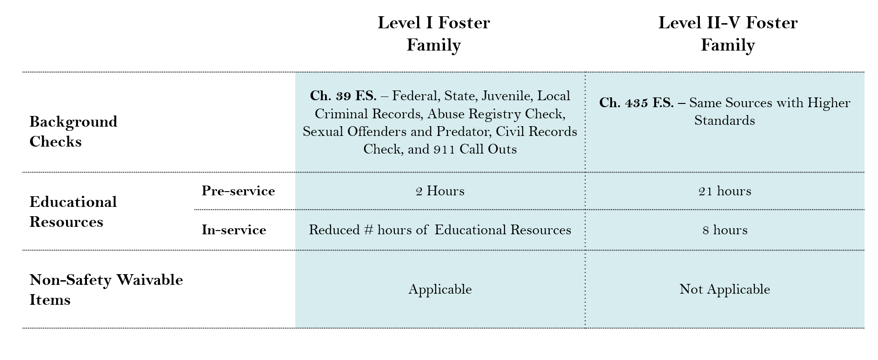_______________________________________________________________________________________________________________________________________________________________________________________________________________________________________________________________

## **Levels of Licensure**

____________________________________________________________________________________________________________________________________________________________________________________________________________________________________________________________________________________________________________________________________________________

# **Guardianship Assistance Program**

## **Guardianship Assistance Program (GAP) Overview:**

* A Title IV-E benefits program that is available to relatives and fictive kin who commit to care for a child long term
* Offers financial assistance and other services, such as Medicaid, to the children and their relatives
* Strengthens permanency for children discharged to permanent guardianship

_______________________________________________________________________________________________________________________________________________________________________________________________________________________________________________________________

_______________________________________________________________________________________________________________________________________________________________________________________________________________________________________________________________

__________________________________________________________________________________________________________________________________________________________________________

## **Guardianship Assistance Program (GAP) Benefits**

GAP benefits are:

* + Monthly payments of $333 for support of the child,
  + Medicaid benefits until 18 years of age (or 21 if eligible for Extension of Guardianship Assistance Program),
  + Tuition and fee exemptions,
  + Available for children who are living out-of-state,
  + One-time payment to assist with the costs of establishing permanent guardianship ($2000 non-recurring).

_______________________________________________________________________________________________________________________________________________________________________________________________________________________________________________________________

_______________________________________________________________________________________________________________________________________________________________________________________________________________________________________________________________

## **Guardianship Assistance Program (GAP) Eligibility Overview**

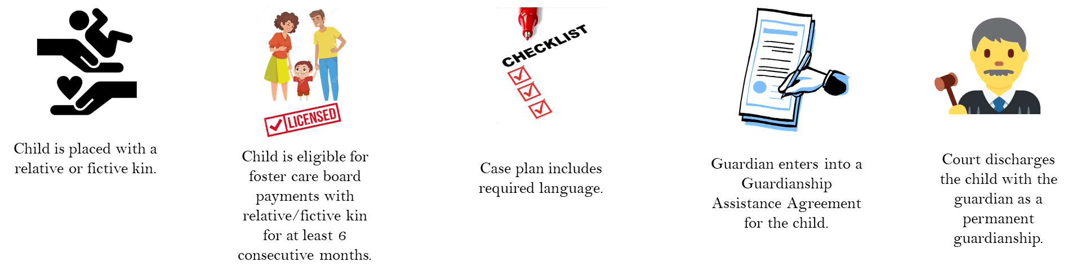

_______________________________________________________________________________________________________________________________________________________________________________________________________________________________________________________________

_______________________________________________________________________________________________________________________________________________________________________________________________________________________________________________________________

_______________________________________________________________________________________________________________________________________________________________________________________________________________________________________________________________

### **Guardianship Assistance Program (GAP) Eligibility Stages Overview**

## **GAP Eligibility Initiation: *Permanent Guardianship Goal***

* Court accepts the primary or concurrent goal of permanent guardianship.
* **Within 30 days of a goal change to permanent guardianship or addition of a concurrent goal of permanent guardianship**, presumptive eligibility must be completed on the child in licensed care with a relative or fictive kin.
* Child Welfare Professional initiates GAP eligibility process in FSFN.

_______________________________________________________________________________________________________________________________________________________________________________________________________________________________________________________________

_____________________________________________________________________________________

## **GAP Presumptive Eligibility: *Child is Placed with a Relative or Fictive Kin***

Child is placed with relative caregiver or fictive kin. _______________________________________________________________________________________________________________________________________________________________________________________________________________________________________________________________

## **GAP Presumptive Eligibility: *Minimum 6 Months of Foster Care Payment***

Relative or Fictive Kin is eligible for foster care board payments for the child for at least 6 consecutive months. _______________________________________________________________________________________________________________________________________________________________________________________________________________________________________________________________

## **GAP Presumptive Eligibility**

* GAA may be initiated once a child has been deemed presumptively eligible. The GAA must be completed in FSFN.
* Once presumptive eligibility has been determined, the child welfare professional shall contact the revenue maximization staff at the CBC office within 15 calendar days to review the Title IV-E eligibility status.

_______________________________________________________________________________________________________________________________________________________________________________________________________________________________________________________________

## **Federal Funding for GAP**

• Revenue Maximization staff should review and update the child’s Title IV-E or TANF eligibility status.

• The child’s Title IV-E or TANF status at discharge to permanent guardianship will be the child's status for GAP.

_______________________________________________________________________________________________________________________________________________________________________________________________________________________________________________________________

_______________________________________________________________________________________________________________________________________________________________________________________________________________________________________________________________

# **What is Important and New for Case Managers?**

## **What is Important for Case Managers?**

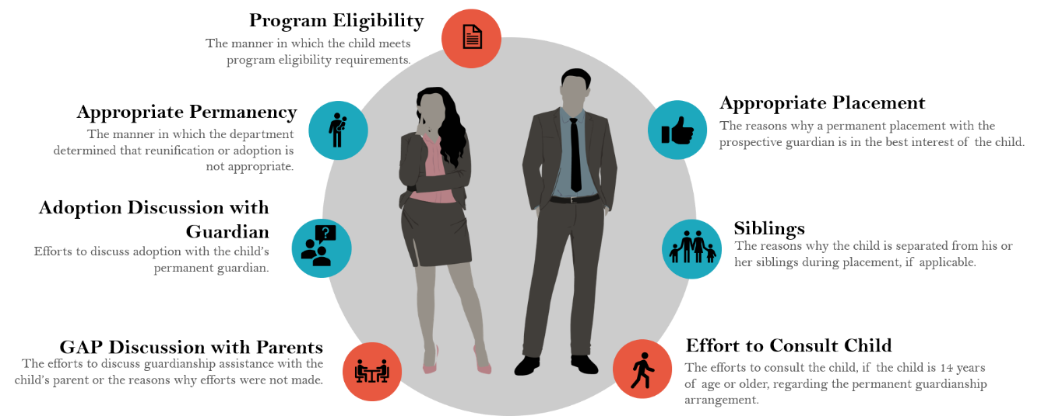Case managers must document the following in the case plan (Ch. 39.6225 F.S.):

**Program Eligibility:** The manner in which the child meets program eligibility requirements

**Appropriate Permanency:** The manner in which the department determined that reunification or adoption is not appropriate.

**Adoption Discussion with Guardian:** Efforts to discuss adoption with the child’s permanent guardian.

**GAP Discussion with Parents:** The efforts to discuss guardianship assistance with the child’s parent or the reasons why efforts were not made.

**Appropriate Placement:** The reasons why a permanent placement with the prospective relative is in the best interest of the child.

**Siblings:** The reasons why the child is separated from his or her siblings during placement, if applicable.

**Effort to Consult the Child:** The efforts to consult the child, if the child is 14 years of age or older, regarding the permanent guardianship arrangement.

**NOTE:** Appropriate Permanency, Relative Not Adopting, Appropriate Placement, and Sibling are required for all case files while Program Eligibility, GAP discussion with parents, and effort to consult child are only required for GAP cases.

_______________________________________________________________________________________________________________________________________________________________________________________________________________________________________________________________

__________________________________________________________________________________________________________________________________________________________________________

## **What is New for Case Managers?**

**Program Eligibility:** How the child will meet the presumptive GAP eligibility requirements.

* The child is placed with a relative or fictive kin.
* The caregiver is a licensed foster home and is eligible for at least 6 consecutive months of foster board payment.

**GAP Discussion with Parents:** The efforts to discuss guardianship assistance with the child’s parent or the reasons why efforts were not made.

* Describe permanent guardianship to the parents
* Discuss GAP and the possibility of reopening the case
* Explain the Guardianship Assistance Program benefits

**Effort to Consult the Child:** The efforts to consult the child, if the child is 14 years of age or older, regarding the permanent guardianship arrangement.

* Describe permanent guardianship to the child
* Explain the Guardianship Assistance Program benefits

_______________________________________________________________________________________________________________________________________________________________________________________________________________________________________________________________

## **Required Language Placement**

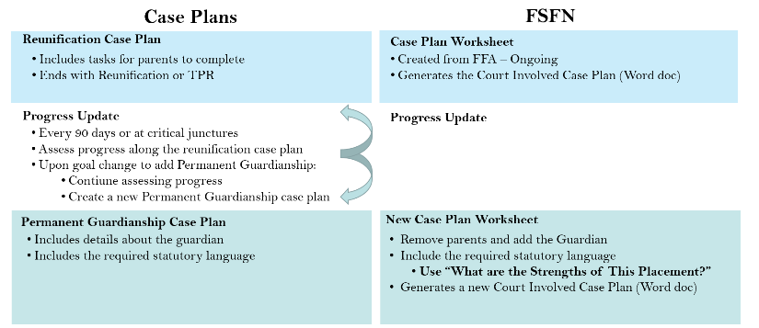

_______________________________________________________________________________________________________________________________________________________________________________________________________________________________________________________________

# **FSFN Guardianship Assistance Program Page**

## **Creating the Guardianship Assistance Program Page**

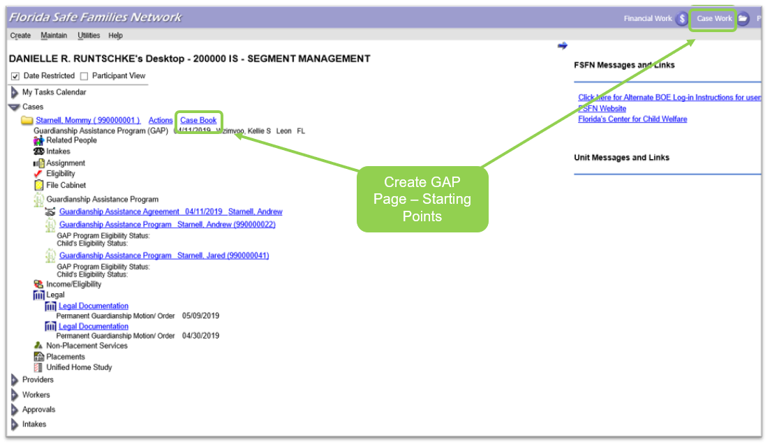

The Guardianship Assistance Program Page can be accessed from two locations on the FSFN desktop, the Case Book hyperlink next to the Case Name, and the Case Work Button at the top of the screen.

_______________________________________________________________________________________________________________________________________________________________________________________________________________________________________________________________

## **Creating the Guardianship Assistance Program Page – Case Work Button**

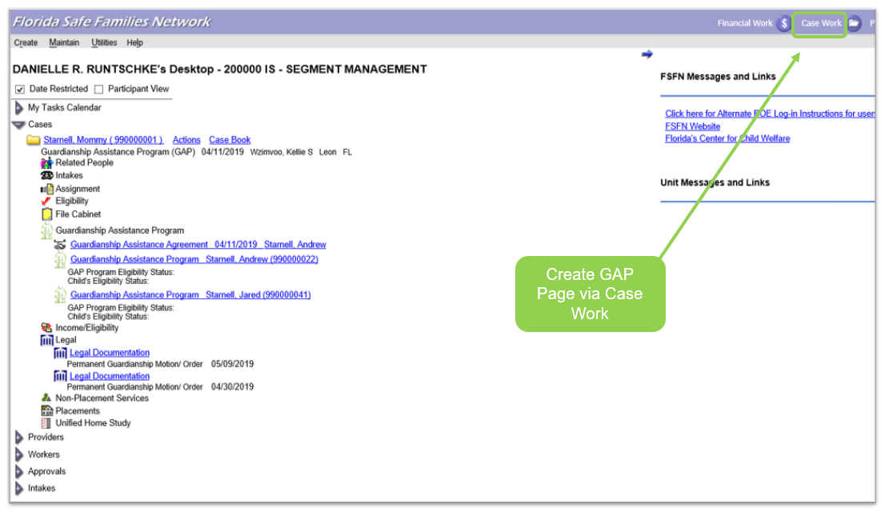

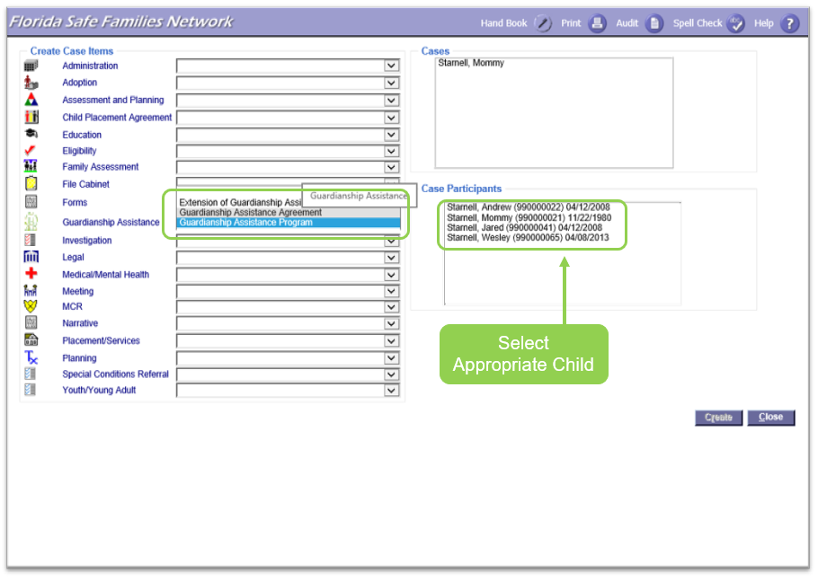

**To access from the Case Work Button:** From the FSFN Desktop, select the Case Work Button. From Create Case Work, select the Case name then select the participant (child), which will receive the payments. On the left side of the page, under the Create Case Items find the label Guardianship assistance. In the drop-down, select Guardian Assistance Program. Double check all selections and select “create” at the bottom right side of the page.

_______________________________________________________________________________________________________________________________________________________________________________________________________________________________________________________________

## **Creating the Guardianship Assistance Program Page – Case Book**

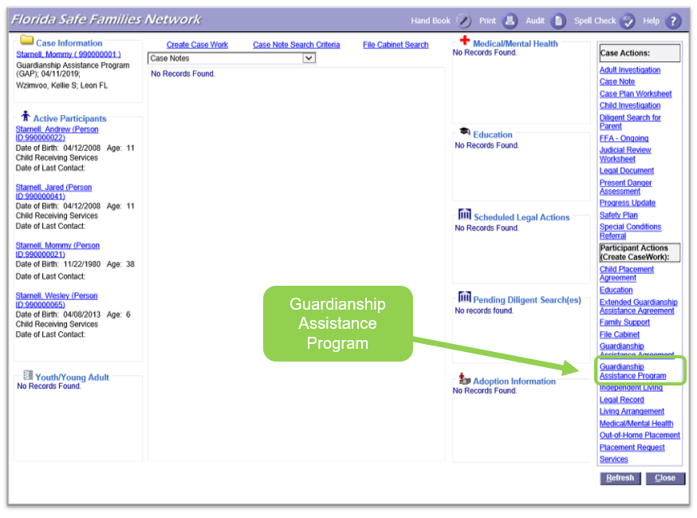

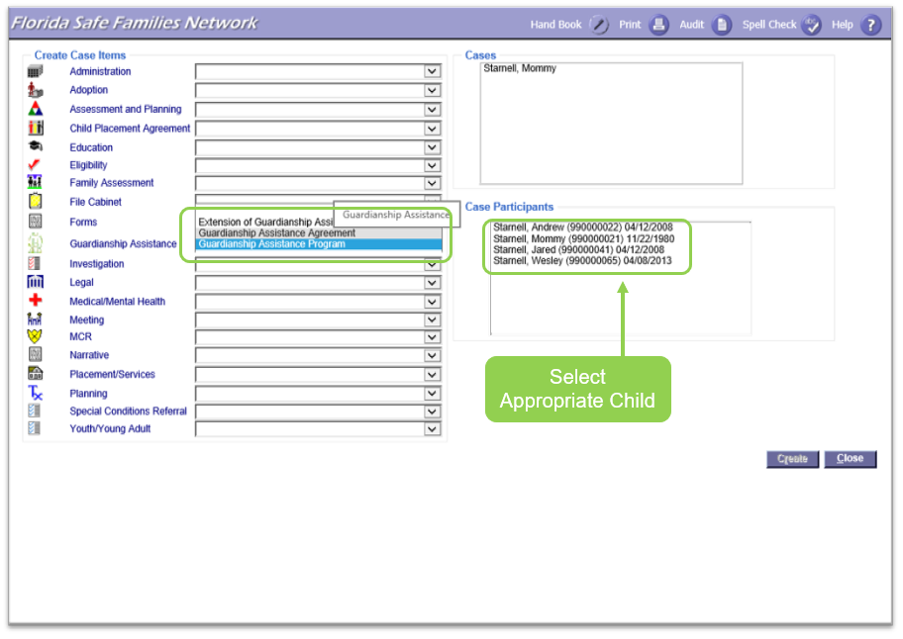

To access from the Case Book Hyperlink, Collapse all Expandos on the left side of the FSFN Desktop. Open the Expando labeled Cases. Select the Case Book hyperlink next to the appropriate Case. On the right side of Case Book, choose Guardianship Assistance Program under the Participant Actions. Select participant (child), which will receive the payments. Double check all selections and select “create” at the bottom right side of the page.

_______________________________________________________________________________________________________________________________________________________________________________________________________________________________________________________________

## **Guardianship Assistance Program (GAP) Eligibility Information – Launch Page**

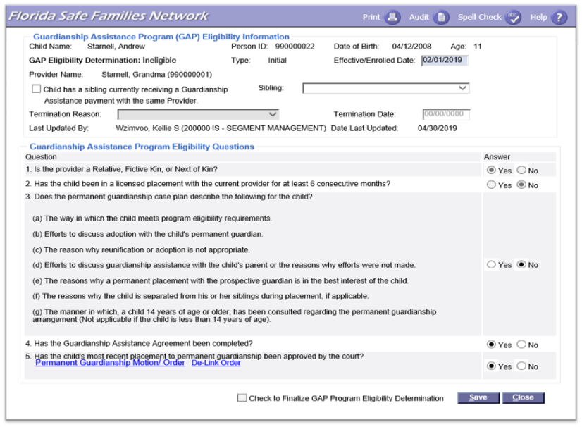**Guardianship Assistance Program (GAP) Page**

## **Guardianship Assistance Program Eligibility Information**

On the Guardianship Assistance (GAP) Eligibility Information Page, select the Insert Button. On the “page name” document the Effective/Enrolled Date as the date of the presumptive eligibility for this child. Questions 1 and 2 will automatically populate based on the information within FSFN. Review question 3(a-g), 4 and 5, and select the appropriate answer, linking any proper documents and court orders. Save the page until all answers are “yes.”

Once all answers are yes, ensure the date reflects a 6-month enrollment time frame. Finally, select “check” to Finalize GAP Program Eligibility Determination” and save the page.

_______________________________________________________________________________________________________________________________________________________________________________________________________________________________________________________________

## **Siblings**

_______________________________________________________________________________________________________________________________________________________________________________________________________________________________________________________________

_______________________________________________________________________________________________________________________________________________________________________________________________________________________________________________________________

### **Documenting Siblings under Guardianship Assistance Program Page**

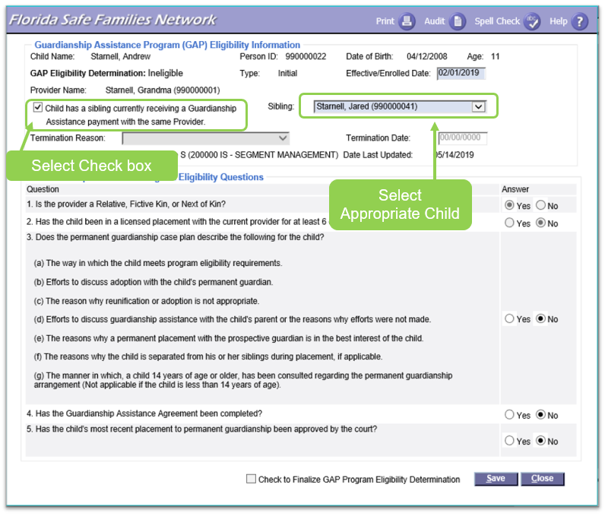

Select the box indicating “child has a sibling currently receiving a Guardianship Assistance payment with the same provider.”

Indicate which sibling in the corresponding box.

By checking this box, question 1 and 2 become grayed out and disabled. _______________________________________________________________________________________________________________________________________________________________________________________________________________________________________________________________

_____________________________________________________________________________________

## **Local Referral Process**

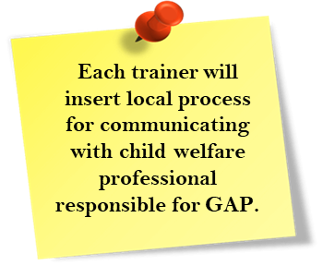Think about the following questions to determine your local referral process to inform child welfare professional responsible for GAP

* How will case managers contact the child welfare professional responsible for GAP?
* Who will do the permanent guardianship case?
* When will case managers contact the child welfare professional responsible for GAP?
* How will child welfare professional responsible for GAP ensure that case managers document required language for GAP?

_______________________________________________________________________________________________________________________________________________________________________________________________________________________________________________________________

# **Extension of Guardianship Assistance Program (EGAP):**

* 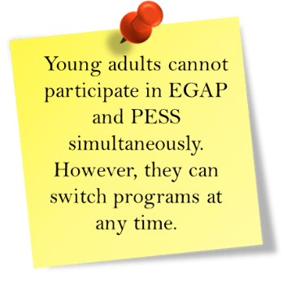Available to caregiver who entered into an initial Guardianship Assistance Agreement (GAA) for a 16- or 17-year-old child
* Available until 21 if the child participates in at least one or more qualifying activities (same qualifying activities as the Extension of Maintenance Adoption Subsidy and Extended Foster Care)
* Allows CBC lead agencies to provide additional support to relatives

_______________________________________________________________________________________________________________________________________________________________________________________________________________________________________________________________

__________________________________________________________________________________________________________________________________________________________________________

